Answers to Tutorial 2

1 (i) Uniqueness, which says that L1 can be paired with at most one point in the right image.
(ii) Continuity constraint (aka disparity gradient) since this assumes that surfaces are locally smooth and hence disparity values are also smooth. So, nearby points in image should have similar disparities (depths), which is violated here. You can also invoke ordering constraint.

2 Epipoles are at x = ∞. The epipolar lines are parallel lines which are parallel to x axis (image rows).

3 0; since it is a fixation point and thus optical axis of both cameras pass through that point which in turn means the image location in both cameras is at (0,0).

4. In this parallel camera configuration, we know Z = (f*b) /|(x _{r} - x _{l} )|.
First, compute image coordinates relative to the principal points: (or you can also use the coordinates given directly).
x _{l t} = 279 - 256 = 23, x _{r t} = 233 - 256 = -23,
y _{l t} = 200 - 256 = -56, y _{r t} = 200 - 256 = -56,
x _{l b} = 276 - 256 = 20, x _{r b} = 236 - 256 = -20,
y _{l b} = 302 - 256 = 46, y _{r b} = 302 - 256 = 46.
Next, compute
Z _{t} = 400 * 100 / |(-23 - 23)| = 870cm (taking magnitude only)
Z _{b} = 400 * 100 / |(-40 )|= 1000cm.
So, the length of the pole in the Z direction is 1000 870 = 130 cm.

5. No. You can figure this out by either visualizing how the different epipolar planes will cut the image planes, or in terms of the location of the epipoles (which will tell you whether the epipolar lines are parallel or not)

6 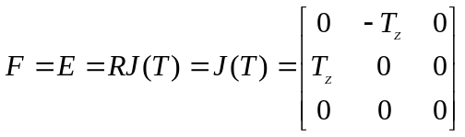
e=e’=(0,0)^{T}

7. J(T)⁺ is not unique as J(T) has rank 2

8. p’ ^{T} F p = 0

9. The relation between F and e/ is given by F e/ = 0 so to find the left epipole, we solve:

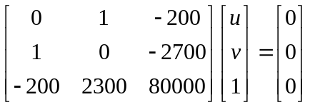

Hence, the left epipole's coordinates are (u, v) = (2700, 200).

10. Find out where the epipole is by finding the null space of the E. Answer: (0,0).

